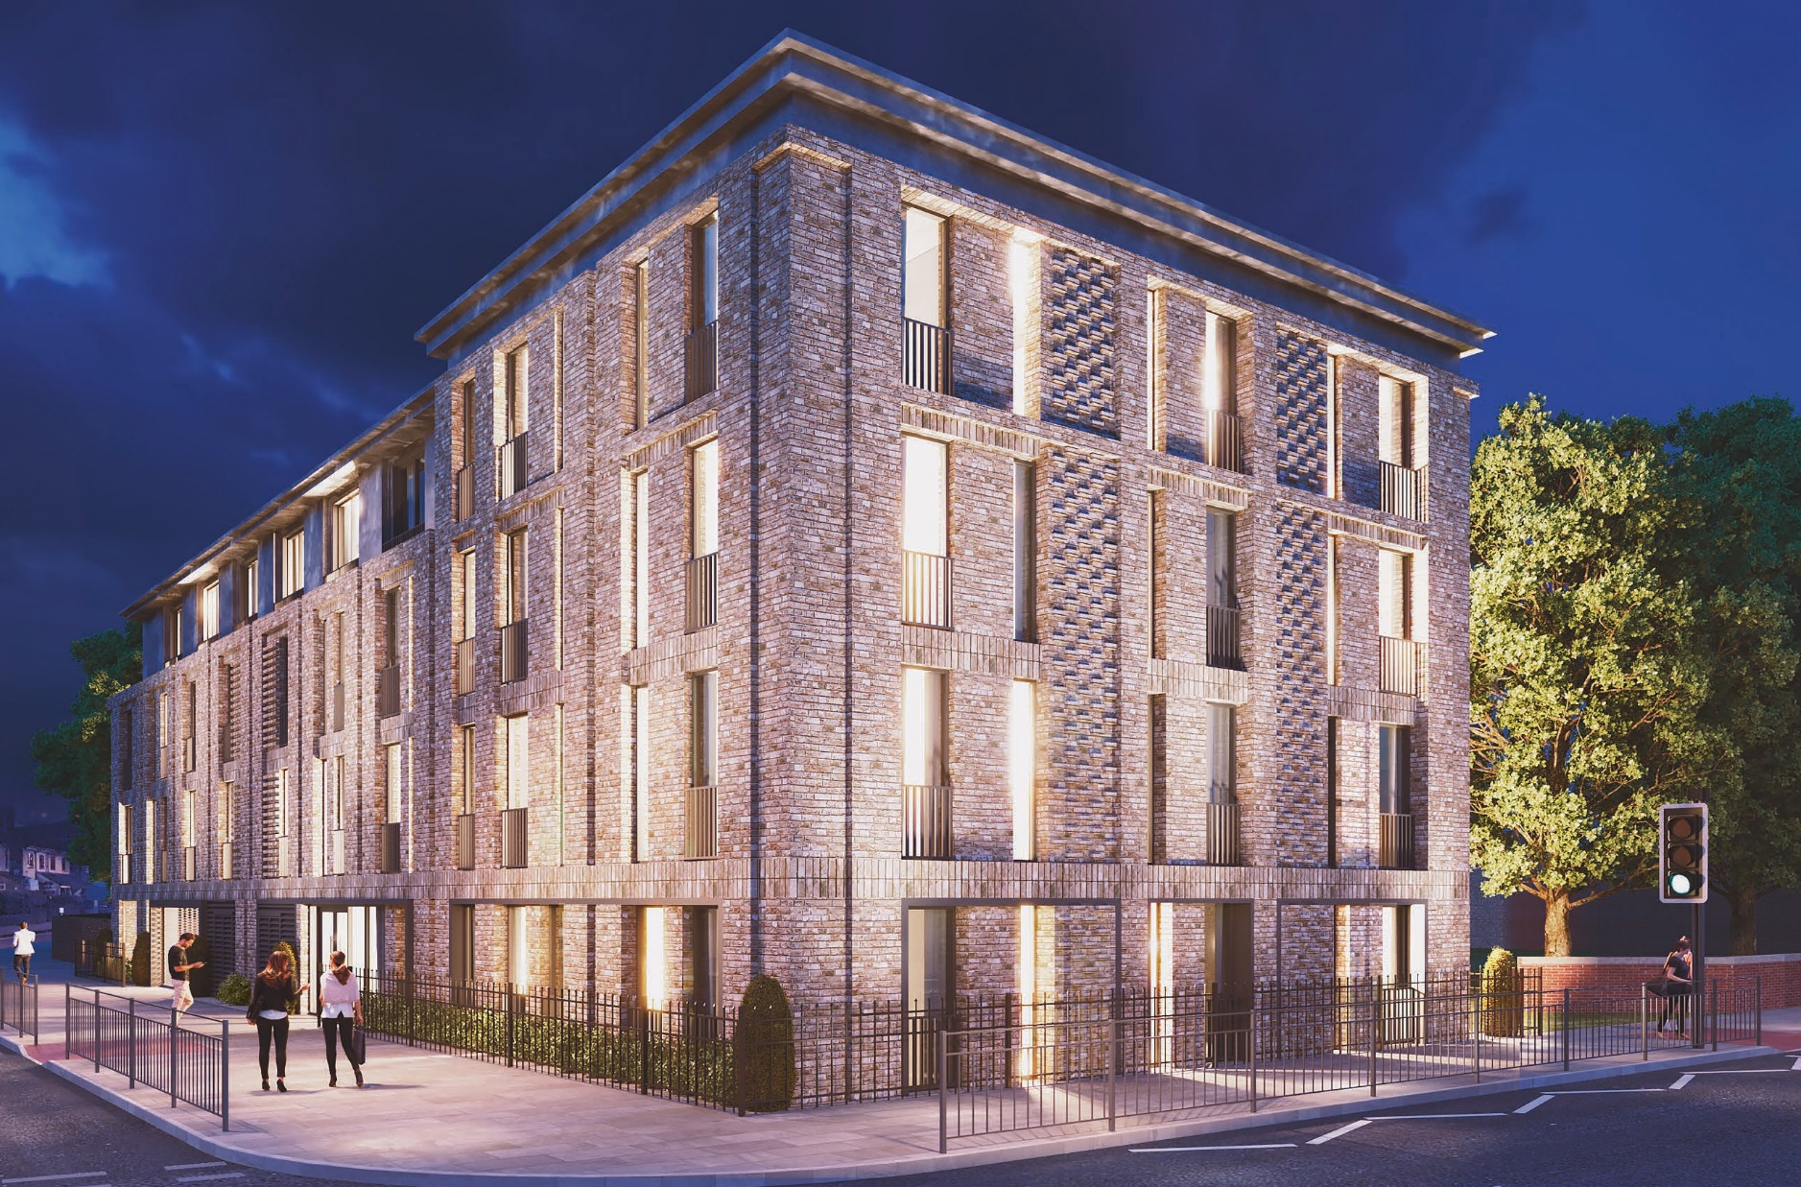
www.sourceddevelopmentgroup.com

Construction Team Update

MAY 2021

Construction Update –
MAY 2021

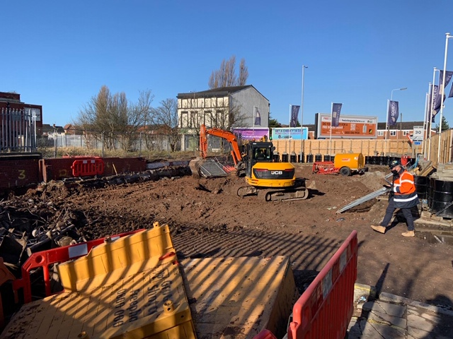

Works completed

Having been granted a road closure to Farnworth Street we quickly finished the foundation works and installed the steel frame rapidly. We have also installed the metal decking and staircase to the 3 floors.
Stud welding and the placement of rebar has taken to the floors. The roof deck has been installed and the metal deck floors concreted

We have made substantial progress on site during the period with works completed including the main drainage connection for the scheme, lightening protection, and scaffolding handrailing and part of the ground floor slab cast.

Current status on site

We are at present installing the final drainage pop ups and currently commencing the facing up of the existing retaining wall and final pour to the ground floor slab.
Orders placed for Windows, SFS, Partitions, Scaffold, Roof, and Brickwork

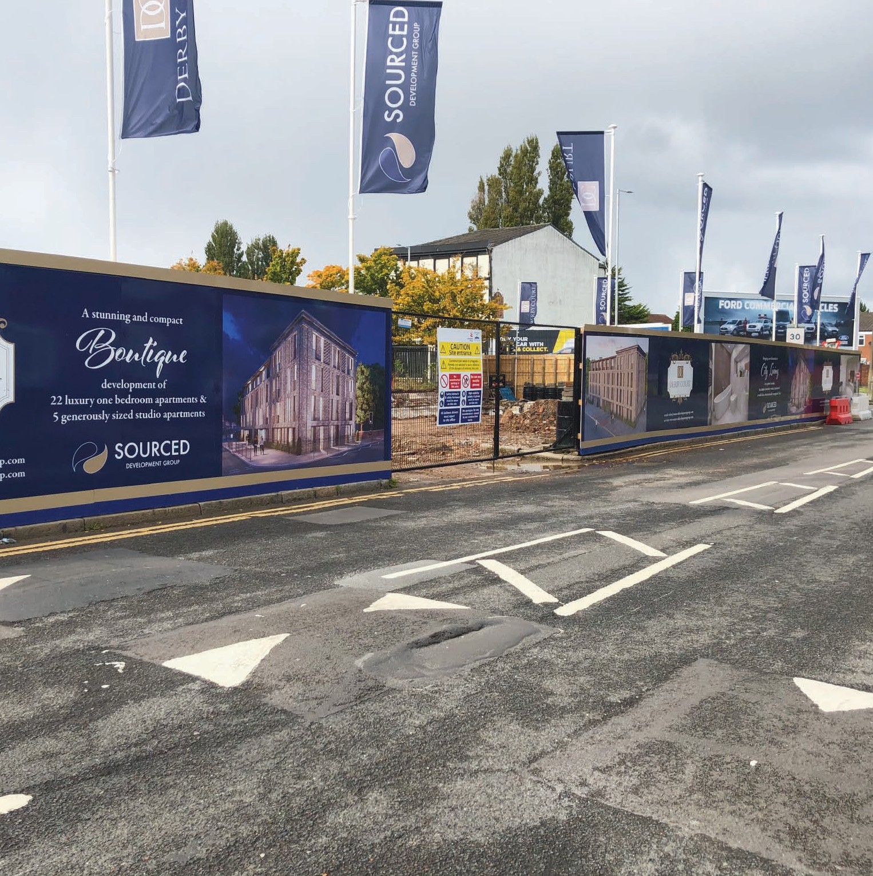

Planned works in the next period.

Commence Roof, Commence SFS and CP Board, Commence Blockwork and Substructure Brickwork, Fire Protection to the Steelwork

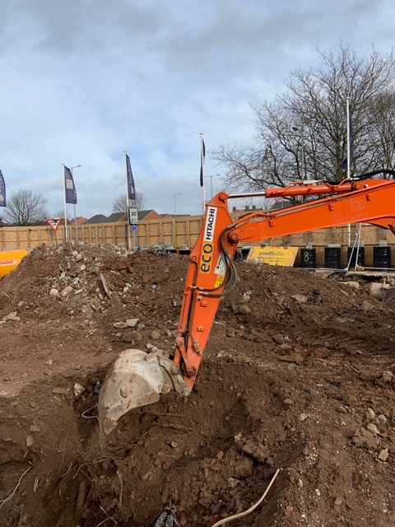

The consultants engaged so far are:

JDA Architects

JDA took over the development at post planning and have been driving the project at fast pace, including intense liaison with the planners to discharge the pre-commencement conditions. Tender information has been provided to test the market and construction drawings and specification issued for construction purposes. As Lead Designer, JDA are coordinating the design.

ADS Structural Engineers

ADS were engaged in September 2020 to provide civil and structural engineering services, working alongside the Architects, MEP Consultants and Sourced Development to progress the civil & structural design.
ADS have provided suitable design and drawings to satisfy the pre- commencement planning conditions, as well as United Utilities’ approval the drainage scheme.
They have also provided design and drawings for foundations and the superstructure steelwork frame.
CC Geotechnical

Completed Phases 1 and 2 ground investigation work and issued their report, which has been submitted to Liverpool City Council. The findings of the report informed the design of the foundations.

QED – M&E Designers

Responsible for the design of all the electrical, plumbing, extract and supply ventilation systems, above ground drainage systems and all other elements of the incoming services.

Sourced Development Group – Principal Designer/CDM

SDG appointed an in house principal designer. The pre-construction information pack, produced by the previous Principal Designer, has been reviewed and found
to be adequate for the project and issued to the Principal Contractor who is Sourced Development Group

Fire Engineer BB7

Initial consultation has been undertaken between JDA Architects and JGA to inform the design, Sourced Construction Group Limited, have confirmed that their preferred Fire Engineering Consultant will be appointed as part of Design & Build Contract

Building Control

Assent Building Control have been employed to carry out all necessary plan checks and to work alongside the other designers to ensure that all required building regulations are achieved.
AEC Acoustic Consultant

Working alongside the architects and other designers to ensure that the acoustic properties of the development satisfy
the standards required. They have issued their report, which will inform the final specification of the external façade.

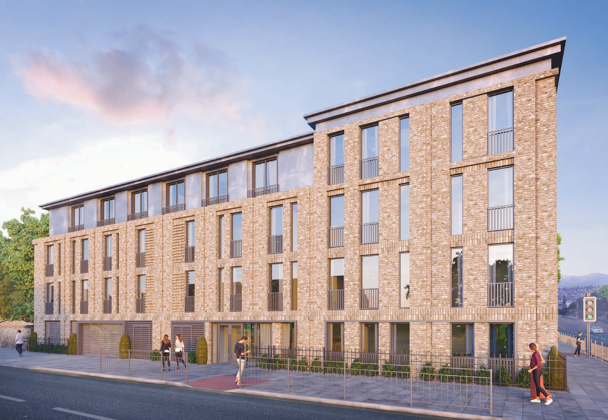

Architectural

JDA Architects have been leading the design and providing suitable information, as well as coordinating the rest of the disciplines.

The apartments layouts are now frozen and JDA will be providing construction status information for all the packages for SCG Limited to facilitate procurement.

General arrangement drawings, sections and elevations have been issued.
The packages to be issued include internal partitions, wall details, fire plans, window schedule, door schedule, kitchen and bathroom layouts.

Finishes schedules are now being produced
JDA have coordinated the pop-locations and services routes, with ADS and
QED, to inform the drainage layout and penetrations through the steelwork beams.

JDA have provided suitable details and drawings for the boundary wall and fence.

Civil & Structural Engineering

ADS Structural Engineering have been liaising with JDA and QED to progress the structural steelwork layouts and issued a set of plans and sections for construction purposes.

ADS have also produced suitable details and drawings, including reinforced concrete details, for the foundations of the project.

Following coordination with JDA and QED, below ground drainage drawings and details have been issued for construction purposes, as well as submission to Liverpool City Council planning department.
In addition, 278 Works details have been provided for the proposed highway works in accordance with the pre-commencement condition.

ADS have attended design team meetings and workshops with the rest of the design team.

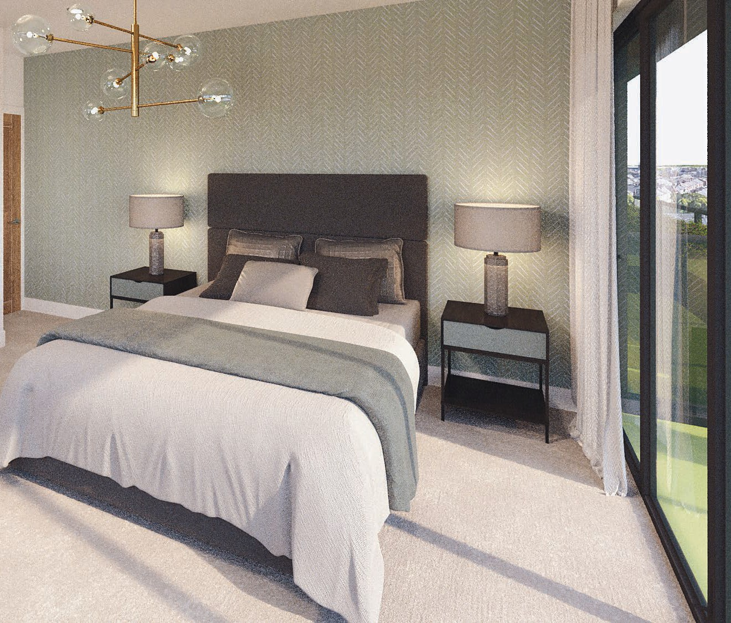

MEP Engineering

QED have completed their design and issued sufficient electrical and mechanical drawings and specifications for the development.

QED have also produced full SAP calculations for all the apartments.

QED have completed the above ground drainage design and advised ADS of the ground floor pop-up locations.

QED have been liaising with the utilities provider and have obtained quotations for water and electric.
QED have completed the services routes layouts and have coordinated the proposed services with ADS to inform the design of the steelwork.

QED have also been attending the design team meetings and workshops with the rest of the design team. NED have been appointed as the Utilities provider and will be working closely with QED to ensure the Power and Water is connected as programme requirements

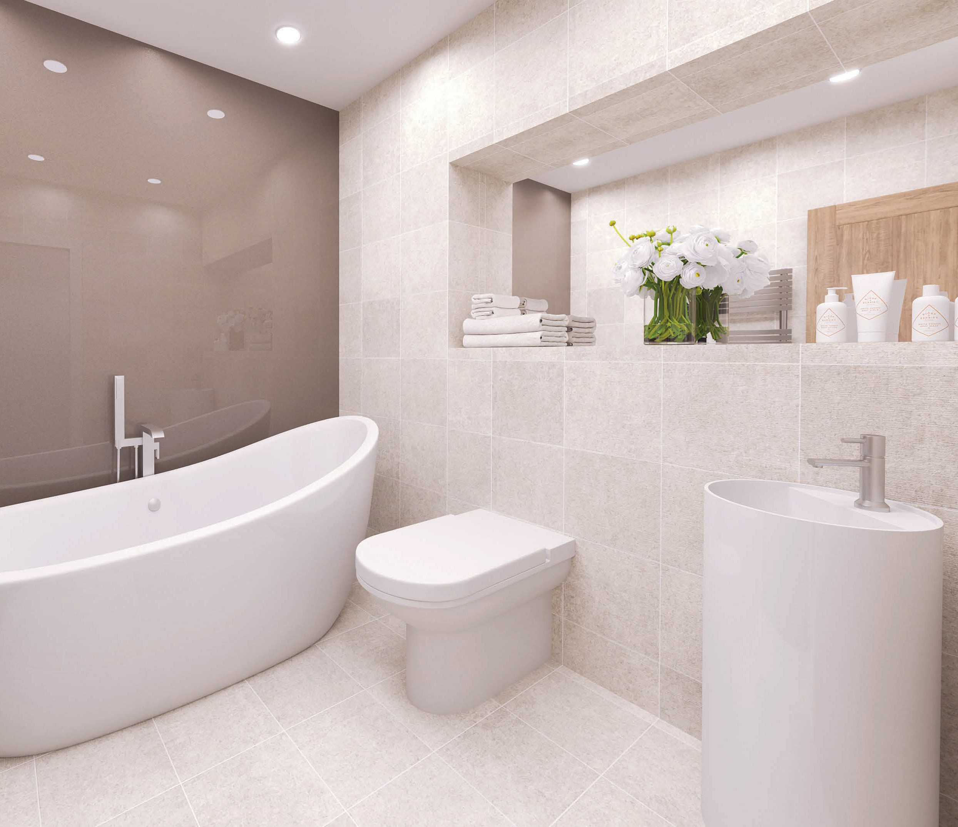

JDA are to produce Finishes Drawings for wall, floors, ceilings and bathroom including fixtures and fittings.
QED will be co-ordinating with JDA regarding bathroom layouts
ADS will be issuing final drawings for the 278 works

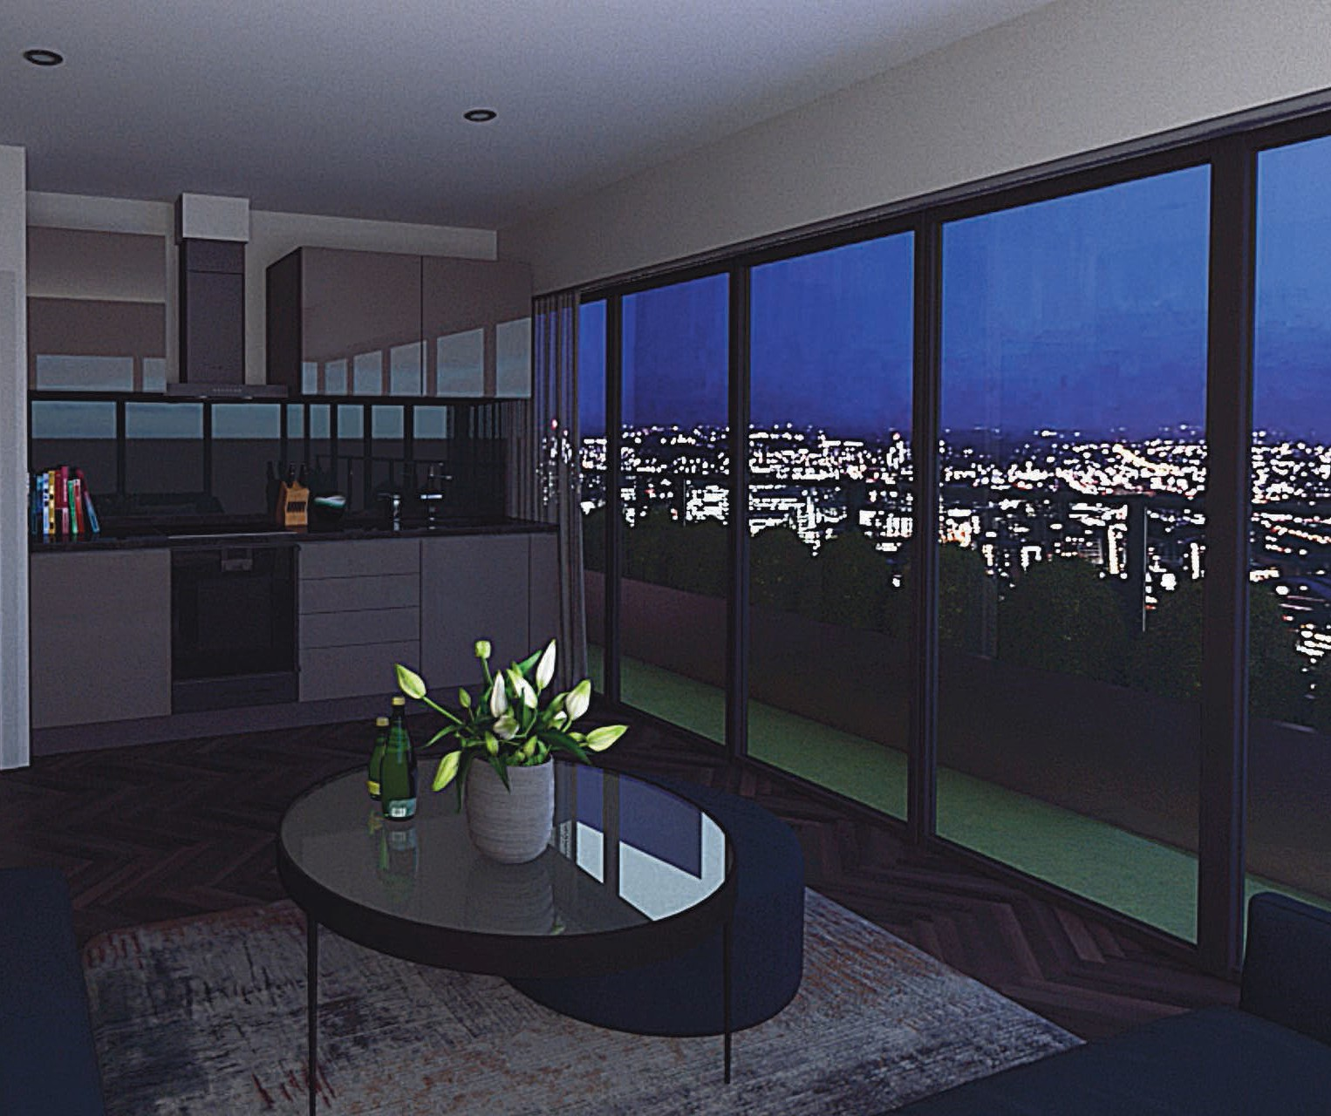

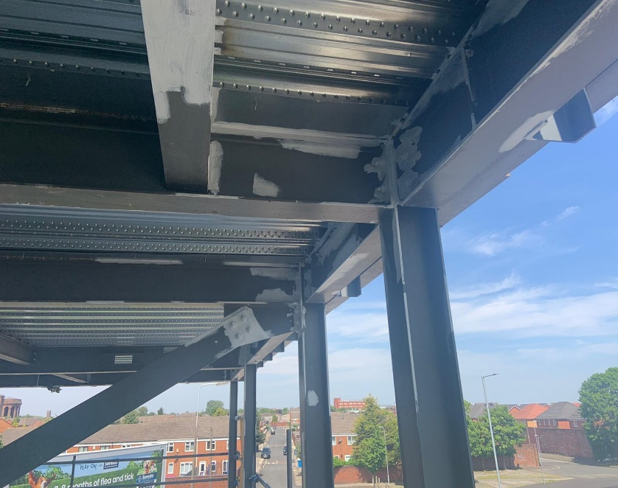
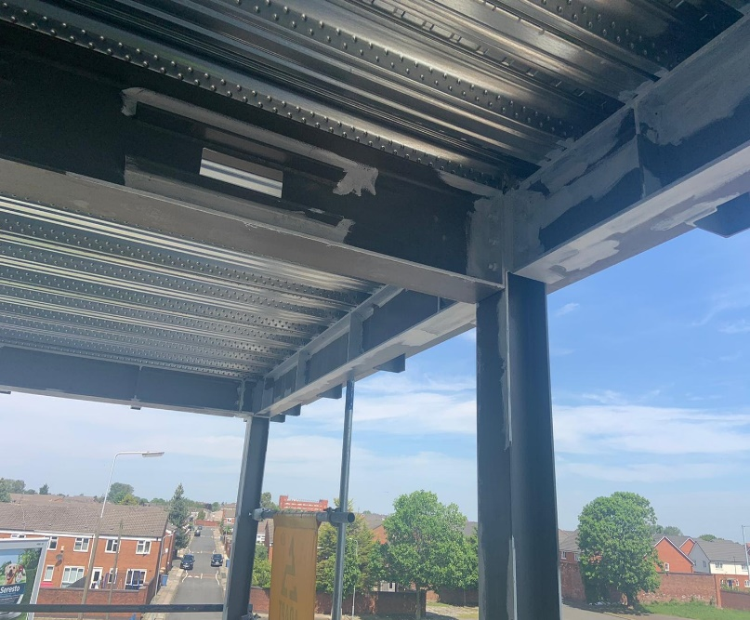

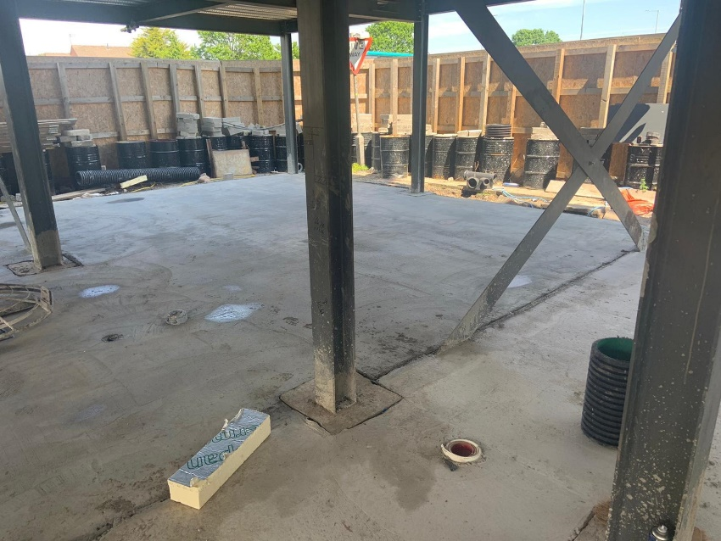
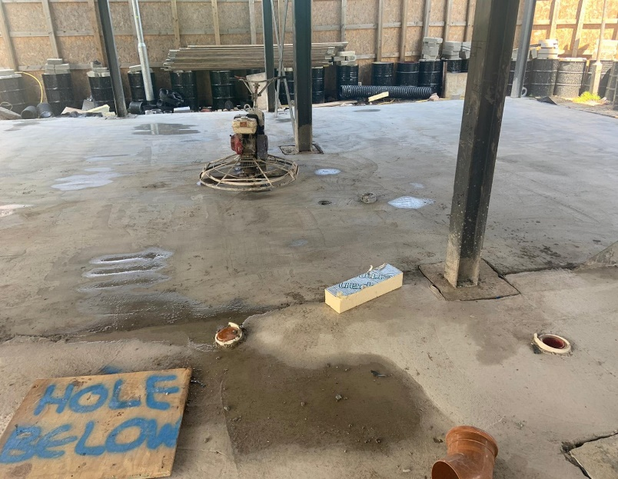

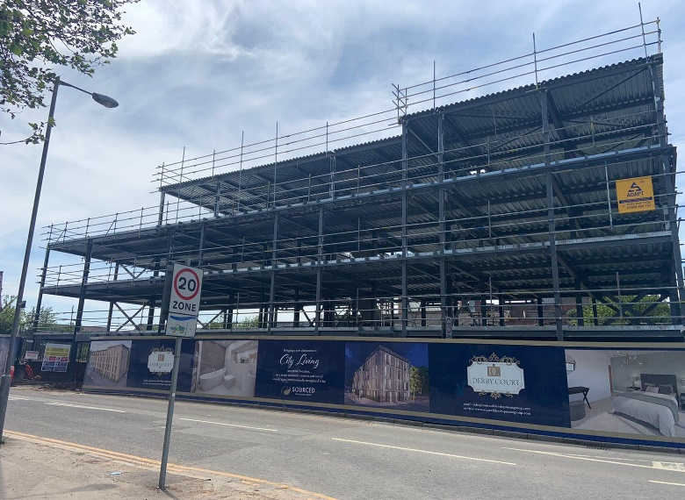
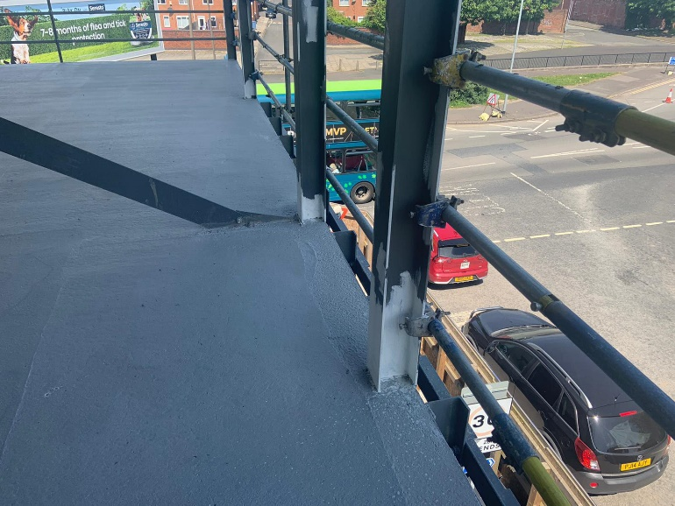

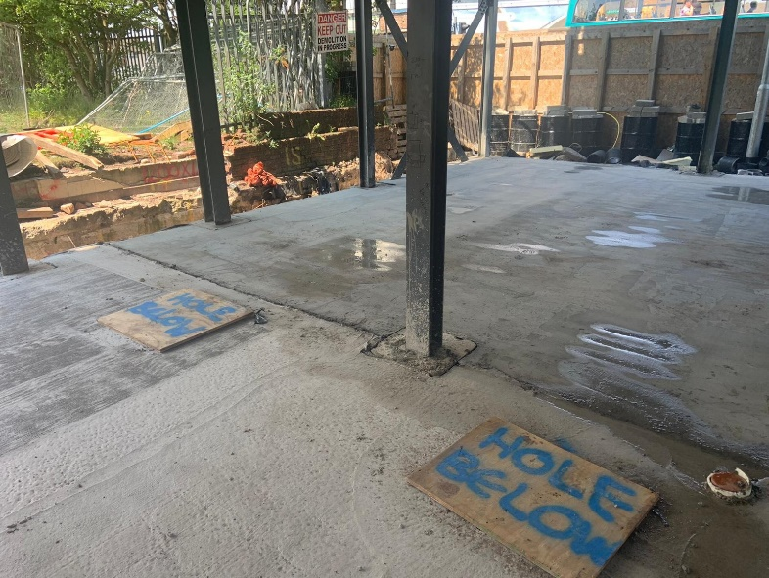
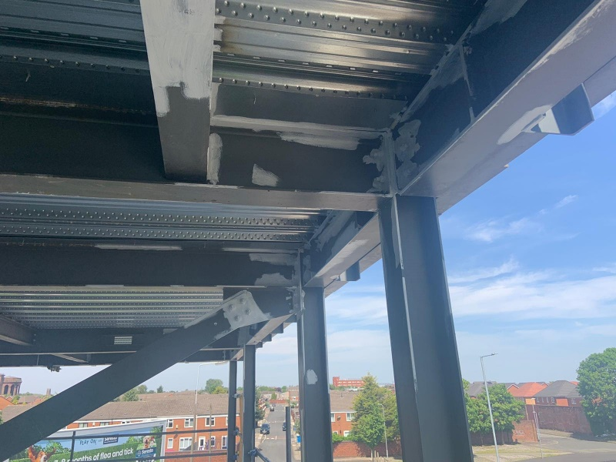

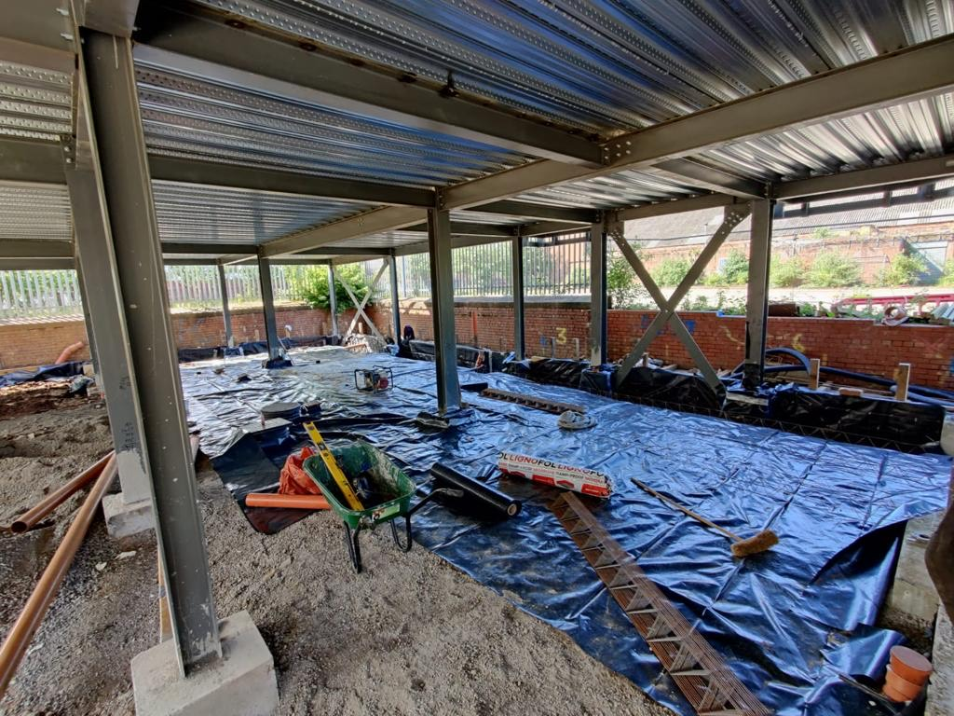
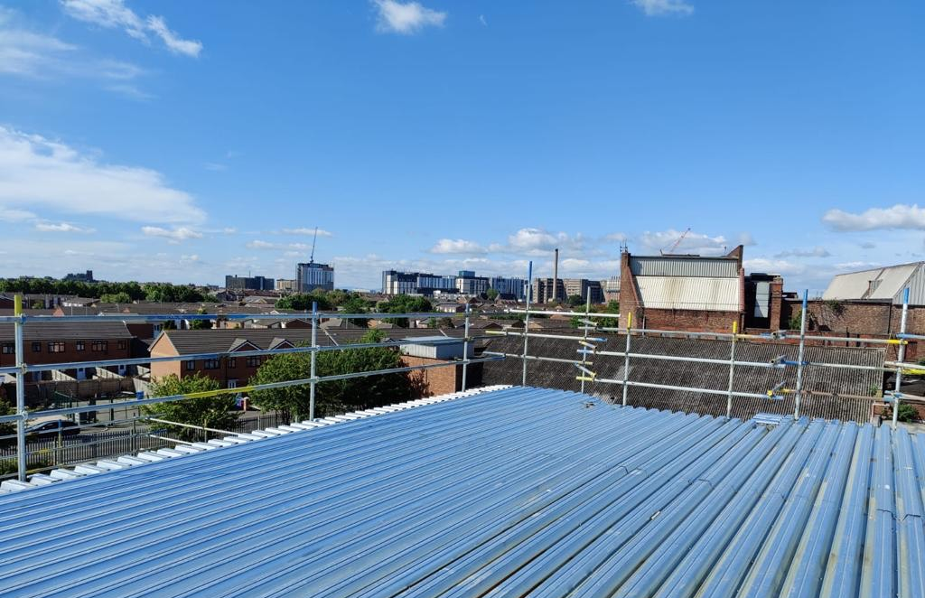
#

www.sourceddevelopmentgroup.com

The information contained with this document is a general guide. This information does not constitute an offer or a contract and we (or anyone in our company) do not imply, make or give any representation, guarantee or
warranty whatsoever relating to the terms contained herein. Any intending investor must satisfy themselves as to the correctness of any of the statements, plans or images contained herein. Images are for reference purposes only.

